**Solenoid Valve Switching IC**

The I/O pins on the Arduino can only source or sink 40mA current and produce voltage upto 5v, so to drive solenoid valves which requires about 12v/300mA we have to use some driver IC like ULN 2803.

**ULN 2803:**

ULN 2803 is a Octal High Voltage, High Current Darlington Transistor Array. This IC is very useful for interfacing between low level digital circuitry and Higher rated current/voltage devices. **The maximum output voltage and current that can be produce by ULN 2803 is 50v/500mA.**

**PIN DIAGRAM:**

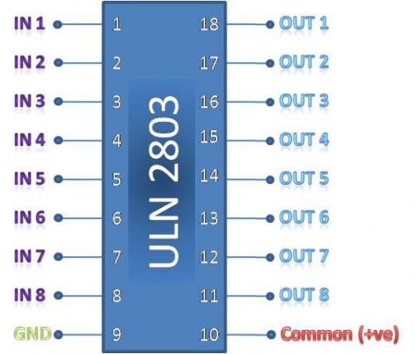

**CIRCUIT DIAGRAM:**

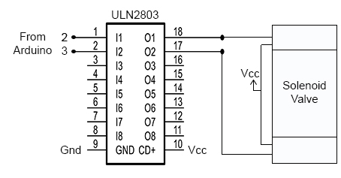

**PROGRAM:**

A simple program to switch alternate channel of solenoid valve with the delay of 1 seconds.

int valve1 = 2;

int valve2 = 3;

void setup()

{

pinMode(valve1, OUTPUT);

pinMode(valve2, OUTPUT);

}

void loop()

{

digitalWrite(valve1, HIGH);

digitalWrite(valve2, LOW);

delay(1000);

digitalWrite(valve2, HIGH);

digitalWrite(valve1, LOW);

delay(1000);

}

**PCB LAYOUT:**

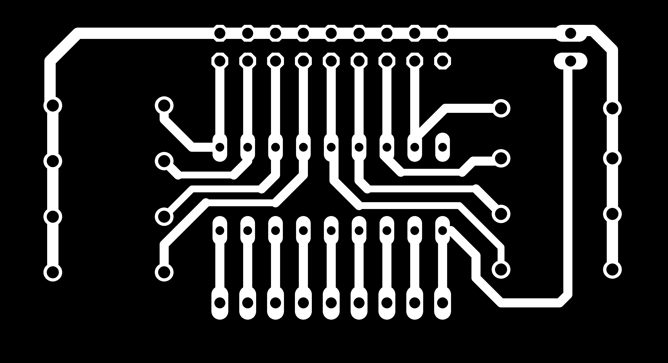

**P.S:** There is no need to add those 8 diodes in ULN2803 circuit.

**DATASHEET:**

For the full detail please refer datasheet of ULN2803:

www.toshiba-components.com/docs/linear/ULN2804APG_en_datasheet.pdf